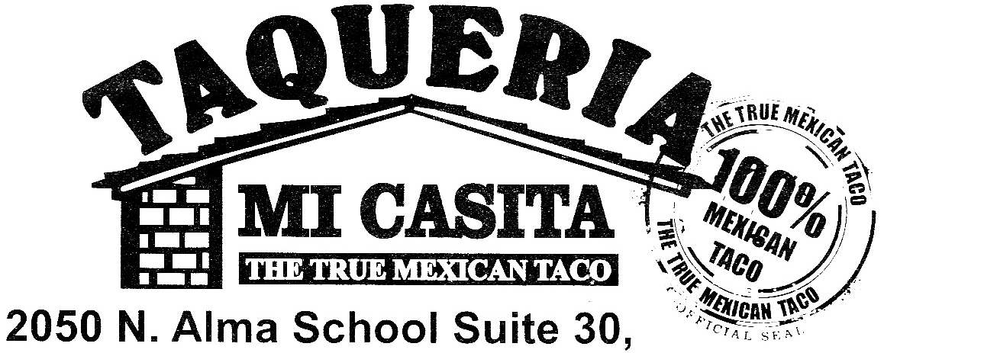
OPEN SINCE 2005
All of our food is fresh and authentic!
*Asada* *Pastor* *Chicken* *Cabeza* *Lengua*
*Carnitas* *Buche* and *Chorizo*

Tacos (choice of meat) 1.99 Side of beans 1.99
Fish Taco 2.59 Side of rice 1.99
Lengua Taco 2.99
Quesadilla(with meat) 7.99
Burro (rice, beans, meat) 5.99 Quesadilla (no meat) 4.49
Bean n cheese Burro 4.49
Vegetarian Burro 5.05 “Rico Menudo” 8.49
Burro Bañado(enchilada style)7.99 Saturday and Sunday
Breakfast Burro 5.49
Meat Only Burro 6.49 Combination Plate 8.99
Fish Burro 6.49 rice, beans, choice of meat, tortillas
Lengua Burro 10.49 3 Taco Combo 6.49
Salads (with meat) 7.29
Nachos with meat 7.99 Tostada (with meat) 4.49
Nachos without meat 5.49 Tostada (no meat) 2.59

Enchiladas(2 w/ rice and beans)6.49 Flan(Grandma’s recipe) 3.25
taqueriamicasita.com
Order to-go at
(480) 814-7047
2050 N. Alma School Rd., Ste. #30
Chandler, AZ 85224
OPEN SINCE 2005
All of our food is fresh and authentic!
*Asada* *Pastor* *Chicken* *Cabeza* *Lengua*
*Carnitas* *Buche* and *Chorizo*

Tacos (choice of meat) 1.99 Side of beans 1.99
Fish Taco 2.59 Side of rice 1.99
Lengua Taco 2.99
Quesadilla(with meat)7.99
Burro (rice, beans, meat) 5.99 Quesadilla (no meat) 4.49
Bean n cheese Burro 4.49
Vegetarian Burro 5.05 “Rico Menudo” 8.49
Burro Bañado(enchilada style)7.99 Saturday and Sunday
Breakfast Burro 5.49
Meat Only Burro 6.49 Combination Plate 8.99
Fish Burro 6.49 rice, beans, choice of meat, tortillas
Lengua Burro 10.49 3 Taco Combo 6.49
Salads (with meat) 7.29
Nachos with meat 7.99 Tostada (with meat) 4.49
Nachos without meat 5.49 Tostada (no meat) 2.59

Enchiladas(2 w/ rice and beans)6.49 Flan(Grandma’s recipe) 3.25 taqueriamicasita.com
Order to-go at
(480) 814-7047
2050 N. Alma School Rd., Ste. #30
Chandler, AZ 85224

